CIS Automotive API

Executive summary:
The plan is to Pull real time market statistics, and raw listing data from the database of over 575M vehicles and 40k dealers from all over the US.
The main key is to VinDecode in which this endpoint is available.
Some of endpoints provide supply, pricing, vehicle, and sales data on the US automotive market on a brand and region basis. They are generated daily from the database of 40k dealerships and over 430M vehicles.
Background :-
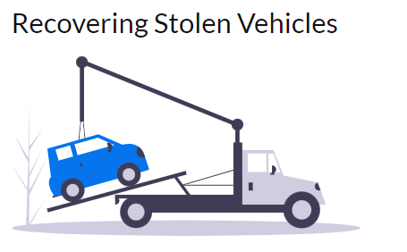

Finding written off losses:-
In this example I want to show how an insurance company or police department might use our API to search for specific vehicles that have been stolen and were never recovered. All that is needed is the Vehicle Identification Number (VIN) and the date the vehicle was stolen.
The database is one of the largest in the industry with the listing and sales data of over 420M vehicles, so whenever a stolen car resurfaces on the open market we'll probably see it.
VinDecode endpoint allows you to decode a VIN and retrieve any available recall information with a single API call.
A Vehicle Identification Number (VIN) is a 17 digit serial number that uniquely identifies a specific vehicle and generally identifies specific features on it. The North American format VIN has 6 sections that identify the manufacturer, country of origin, vehicle attributes, the model year, the production plant, a serial number, and a check digit.
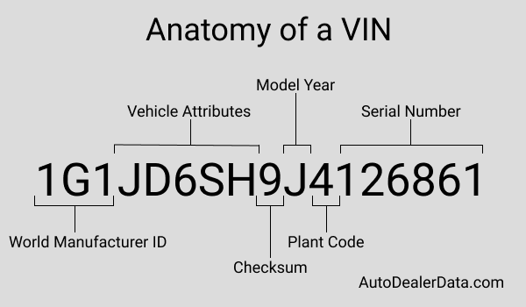
As we'll see when we make a vin lookup API request, the above VIN corresponds to a 2018 Chevrolet Sonic LT that was built in Orion Michigan. We'll also see that GM issued a recall notice for some 2018 Sonics on May 27, 2018 to fix a weld affecting the safety of the driver's seat.
We can still do a little decoding by just looking at the vin however. The first character "1" tells us the country of origin is the US and the next two ("G1") tell us it is a Chevrolet passenger car. To determine the year we can look up the value in a table to see that "J" corresponds to 2018, or we could also just say the alphabet from "A" (2010) until we get to "J". The letters "I", "O", and "Q" are not used in VINs, so we skip those when we say the alphabet. "U", "Z", and the number "0" can appear in a VIN, but they are not used for the model year field, so we would skip those too if we got to them.
We can also go further and use the vehicle history endpoint to see that it first sold in mid August 2018 with an MSRP of $20,885 and ask price of $13,885, that it was later put up for sale again in mid January 2020 as a Certified Pre Owned (CPO) vehicle with an original ask price of $14,750 and sold in mid Febuary with about 36k miles at an ask price of $11,500.

Project approach:-
Kafka is chosen as a data ingestion tool that I am going to use to upload the data into HDFS. There are several reasons why do I prefer the kafka as an ingestion tool as the data is streaming data for this project.
- Apache Kafka acts as a buffer so your systems won’t crash.
- Reduces the need for multiple integrations as per the picture shown below.

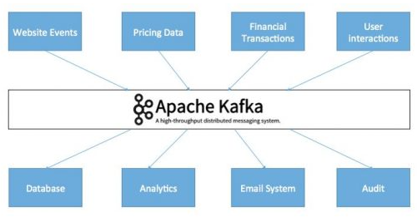
- Low latency and high throughput.
- Everyone can access data.

Conclusion:-
As mentioned with this API I expect will be able to get the market trends and also finding written off losses in the automobile market based on regions and sales in US.

